

# 

### Semester Two Examination, 2017

### Question/Answer booklet

# MATHEMATICS

**SOLUTIONS**

**APPLICATIONS**

**UNITS 3 AND 4**

## Section Two:

## Calculator-assumed

|  |  |  |  |  |  |  |  |  |  |  |
| --- | --- | --- | --- | --- | --- | --- | --- | --- | --- | --- |
| Student Number: In figures |  |  |  |  |  |  |  |  |  |  |

In words

Your name

## Time allowed for this section

Reading time before commencing work: ten minutes

Working time: one hundred minutes

## Materials required/recommended for this section

***To be provided by the supervisor***

This Question/Answer booklet

Formula sheet (retained from Section One)

***To be provided by the candidate***

Standard items: pens (blue/black preferred), pencils (including coloured), sharpener, correction fluid/tape, eraser, ruler, highlighters

Special items: drawing instruments, templates, notes on two unfolded sheets of A4 paper, and up to three calculators approved for use in this examination

## Important note to candidates

No other items may be taken into the examination room. It is **your** responsibility to ensure that you do not have any unauthorised material. If you have any unauthorised material with you, hand it to the supervisor **before** reading any further.

## Structure of this paper

|  |  |  |  |  |  |
| --- | --- | --- | --- | --- | --- |
| Section | Number of questions available | Number of questions to be answered | Working  time (minutes) | Marks available | Percentage of examination |
| Section One:  Calculator-free | 7 | 7 | 50 | 52 | 35 |
| Section Two:  Calculator-assumed | 12 | 12 | 100 | 98 | 65 |
|  | | |  | **Total** | 100 |

## Instructions to candidates

1. The rules for the conduct of examinations are detailed in the school handbook. Sitting this examination implies that you agree to abide by these rules.

2. Write your answers in this Question/Answer booklet.

3. You must be careful to confine your response to the specific question asked and to follow any instructions that are specified to a particular question.

4. Additional working space pages at the end of this Question/Answer booklet are for planning or continuing an answer. If you use these pages, indicate at the original answer, the page number it is planned/continued on and write the question number being planned/continued on the additional working space page.

5. Show all your working clearly. Your working should be in sufficient detail to allow your answers to be checked readily and for marks to be awarded for reasoning. Incorrect answers given without supporting reasoning cannot be allocated any marks. For any question or part question worth more than two marks, valid working or justification is required to receive full marks. If you repeat any question, ensure that you cancel the answer you do not wish to have marked.

6. It is recommended that you do not use pencil, except in diagrams.

7. The Formula sheet is not to be handed in with your Question/Answer booklet.

Section Two: Calculator-assumed 65% (98 Marks)

This section has**twelve (****12)** questions. Answer **all** questions. Write your answers in the spaces provided.

Working time: 100 minutes.

Question 8 (5 marks)

The scatterplot below shows the daily sales of take-away coffees on the -axis and canned drinks on the -axis for a market stall.

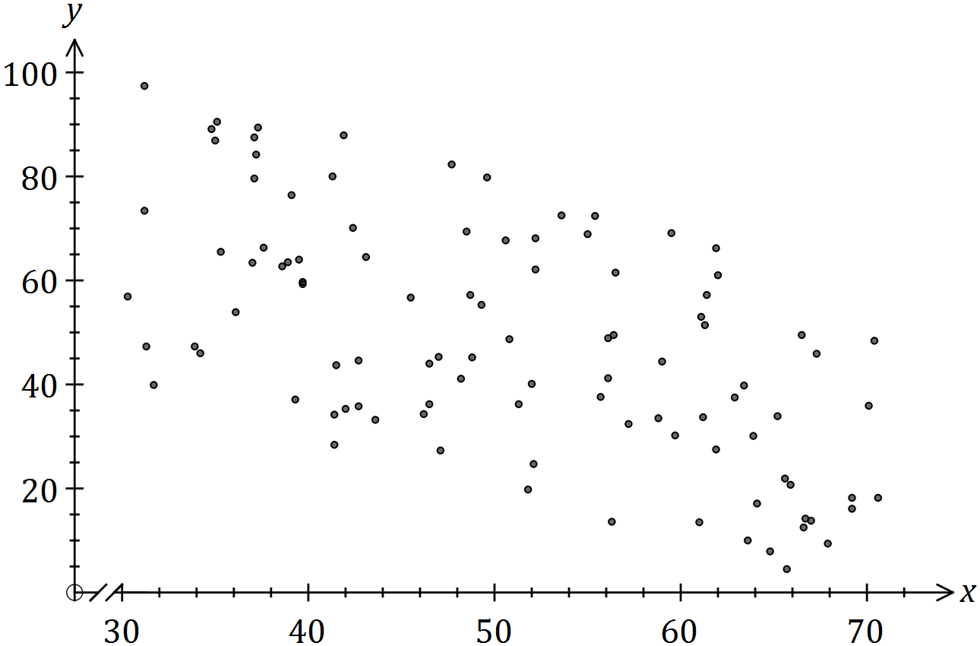

(a) Describe the association between the variables in terms of strength and direction.

(2 marks)

|  |
| --- |
| **Solution** |
| Association is moderate and negative. |
| **Specific behaviours** |
| ✓ indicates strength is moderate  ✓ indicates direction is negative |

(b) The equation of the least-squares line that fits the data is . Interpret the slope of this line. (2 marks)

|  |
| --- |
| **Solution** |
| For every extra coffee sold during a day, the number of canned drinks sold decreases by 1.2. |
| **Specific behaviours** |
| ✓ as increases, decreases  ✓ uses variable names and uses 1.2 |

(c) Identify a possible non-causal explanation for the association between the variables.

(1 mark)

|  |
| --- |
| **Solution** |
| Coincidence; Confounding due to variable such as temperature, people will buy one or the other, but not both etc. |
| **Specific behaviours** |
| ✓ any plausible reason |

Question 9 (9 marks)

A researcher sought to determine whether a person's support for a particular political party affected their approval of a proposal to expand the Snowy Hydro scheme.

|  |  |  |  |  |
| --- | --- | --- | --- | --- |
|  | Vote Labour | Vote Lib/Nat | Vote other | Total |
| Approve |  |  |  |  |
| Disapprove |  |  |  |  |
| Don't know |  |  |  |  |
| Total |  |  |  |  |

(a) Complete the three missing entries in the table above. (2 marks)

(b) State which is the response variable and which is the explanatory variable. (2 marks)

|  |
| --- |
| **Solution (a)** |
| See table |
| **Specific behaviours** |
| ✓ completes second row  ✓ completes second column |

|  |
| --- |
| **Solution (b)** |
| Response: Approval of SH scheme  Explanatory: Political party |
| **Specific behaviours** |
| ✓ response variable  ✓ explanatory variable |

(c) Explain why creating a table of column percentages, rather than row percentages, is appropriate in this instance. (1 mark)

|  |
| --- |
| **Solution** |
| Columns contain explanatory variable |
| **Specific behaviours** |
| ✓ uses explanatory variable |

(d) Complete the table of column percentages below. (2 marks)

|  |
| --- |
| **Solution** |
| See table |
| **Specific behaviours** |
| ✓ three entries correct  ✓ fourth entry correct |

|  |  |  |  |
| --- | --- | --- | --- |
| % | Vote Labour | Vote Lib/Nat | Vote other |
| Approve |  |  |  |
| Disapprove |  |  |  |
| Don't know |  |  |  |
| Total |  |  |  |

(e) Comment, with reasons, on whether any evidence exists to suggest that a person's support for a particular political party affected their approval of the proposal to expand the Snowy Hydro scheme. (2 marks)

|  |
| --- |
| **Solution** |
| No - there is no evidence of an association.  There is very little difference in the column percentages for each response category. |
| **Specific behaviours** |
| ✓ states no  ✓ supports answer by noting similarities in column percentages |

Question 10 (8 marks)

A student was asked to estimate the length of lines generated at random on a computer screen. The actual and estimated lengths, in cm, are shown in the graph and table below.

|  |  |  |  |  |  |  |  |  |  |  |  |
| --- | --- | --- | --- | --- | --- | --- | --- | --- | --- | --- | --- |
| Actual length, | 5 | 12 | 11 | 14 | 8 | 10 | 18 | 16 | 6 | 15 | 20 |
| Estimated length, | 10 | 9 | 14 | 11 | 7 | 11 | 20 | 13 | 9 | 17 | 18 |

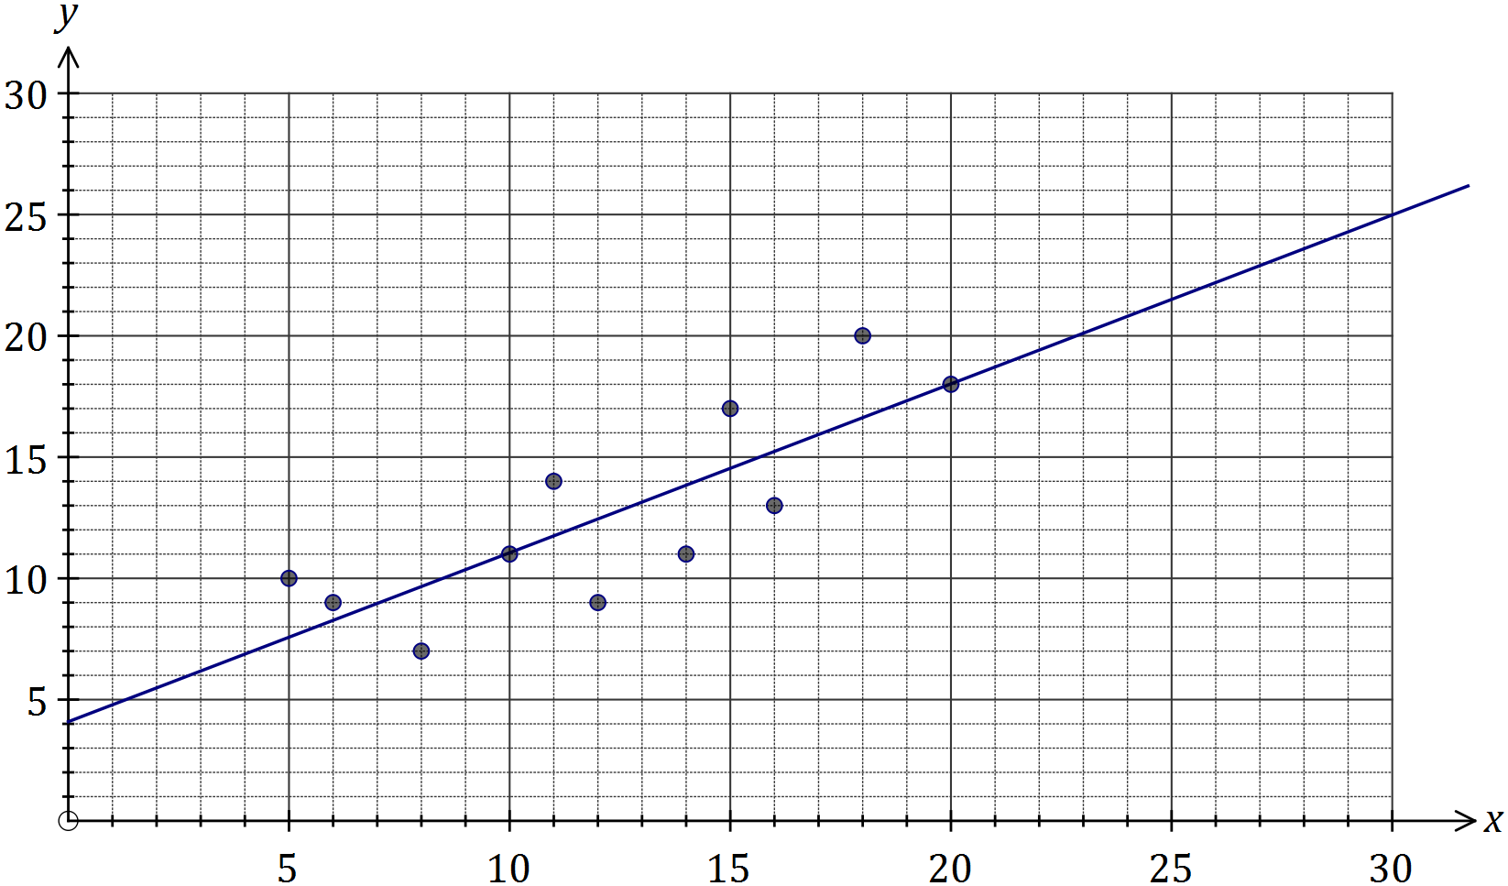

|  |
| --- |
| **Solution (b)(ii)** |
| See graph |
| **Specific behaviours** |
| ✓ through and  ✓ uses ruler |

(a) Calculate the correlation coefficient between the variables and . (1 mark)

|  |
| --- |
| **Solution** |
|  |
| **Specific behaviours** |
| ✓ value to at least 2 dp |

(b) A least-squares line can be used to model the relationship between and .

|  |
| --- |
| **Solution** |
|  |
| **Specific behaviours** |
| ✓ states equation  ✓ both coefficients to at least 2 sf |

(i) Determine the equation of this line. (2 marks)

(ii) Draw this line on the graph. (2 marks)

(c) Predict the student's estimate, to the nearest cm, when the actual length of the line was 24 cm and comment on factors affecting the reliability of this prediction. (3 marks)

|  |
| --- |
| **Solution** |
| Prediction is unreliable as despite strong correlation the prediction involves extrapolation beyond the given data. |
| **Specific behaviours** |
| ✓ correct value  ✓ uses correlation coefficient  ✓ uses extrapolation |

Question 11 (12 marks)

Every afternoon, 25 litres of water is taken from a tank and poured into a small garden pond. At the start of the first day the tank contains 300 L and the pond contains 40 L.

The amount of water in the tank at the start of day is given by .

(a) Complete the table below. (1 mark)

|  |  |  |  |  |  |  |  |  |
| --- | --- | --- | --- | --- | --- | --- | --- | --- |
|  |  |  |  |  |  |  |  |  |
| (L) | 300 | 275 | 250 | 225 | 200 | 175 | 150 | 125 |

(b) Deduce a rule for the amount of water in the tank at the start of the th day. (2 marks)

|  |
| --- |
| **Solution (b)** |
|  |
| **Specific behaviours** |
| ✓ uses th term rule  ✓ correct rule (expanded and simplified) |

|  |
| --- |
| **Solution (a)** |
| See table |
| **Specific behaviours** |
| ✓ all correct |

(c) Graph the amount of water in the tank at the start of day on the axes below. (2 marks)

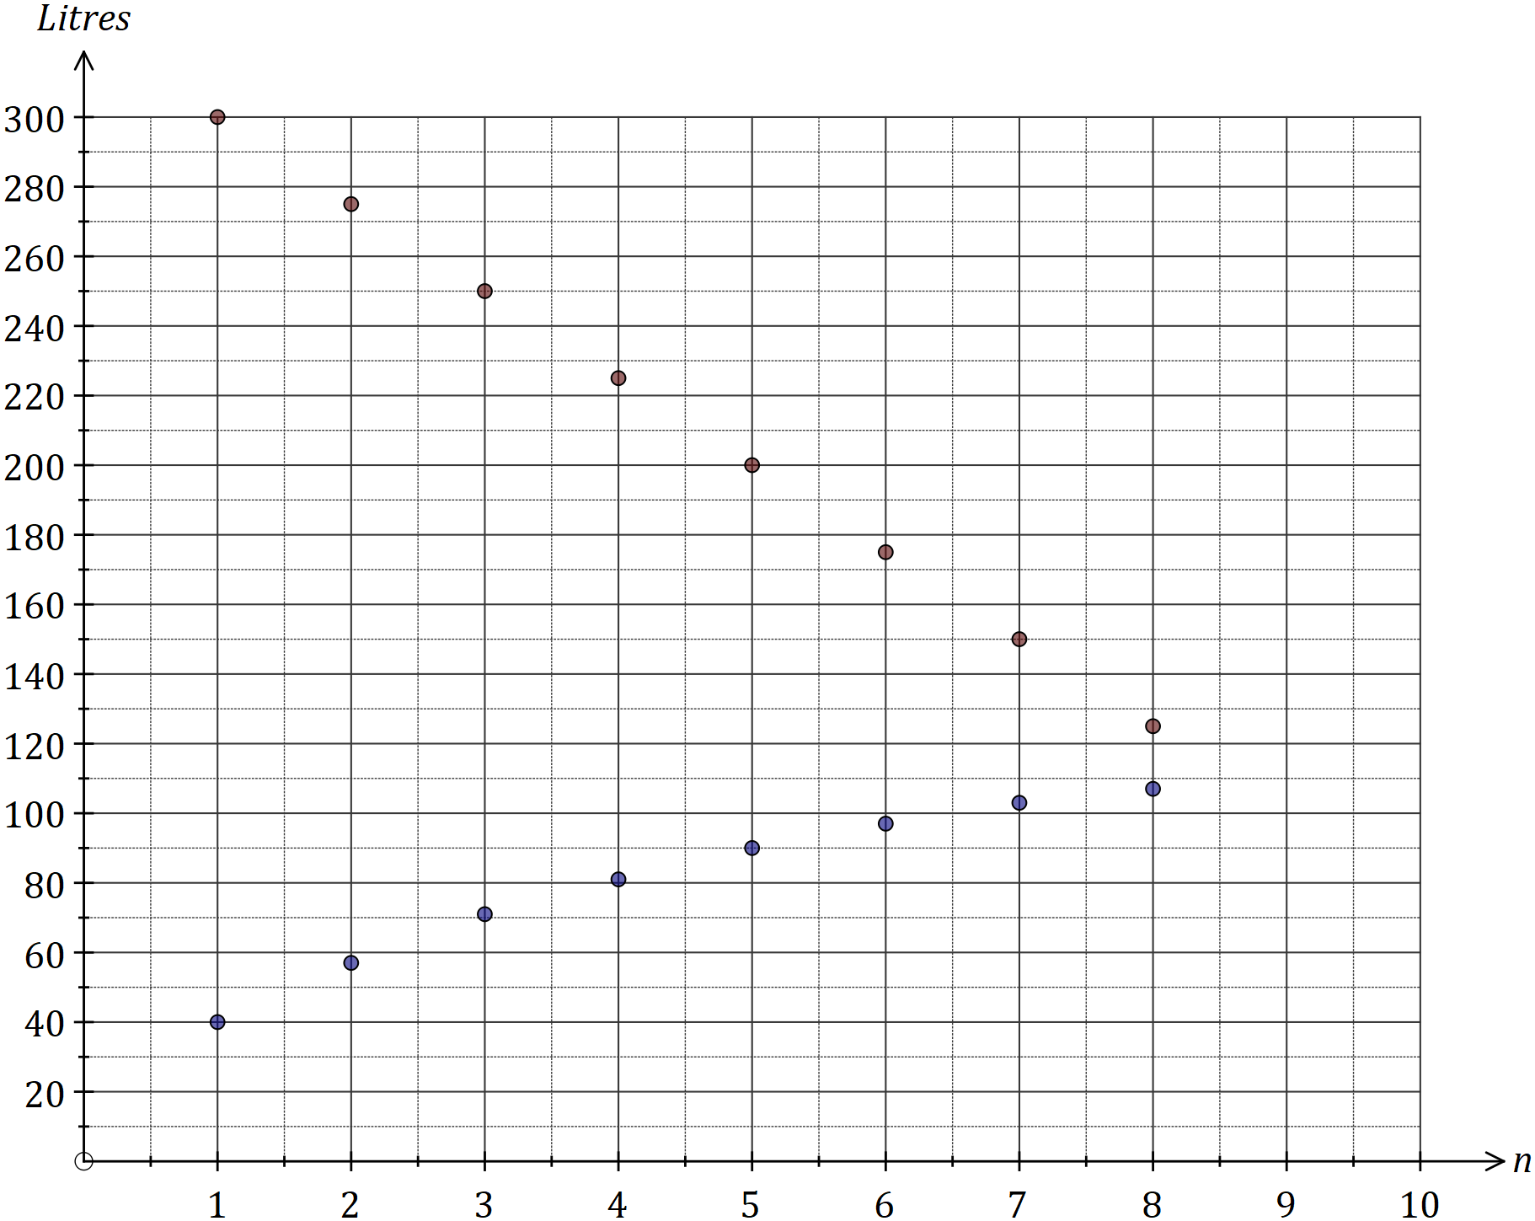

|  |
| --- |
| **Solution (c)** |
| See graph |
| **Specific behaviours** |
| ✓ plots points correctly  ✓ does not join, or joins with steps |

|  |
| --- |
| **Solution (e)** |
| See graph |
| **Specific behaviours** |
| ✓ plots points correctly  ✓ does not join, or joins with sawtooth |

Due to the combined effects of evaporation and water being added from the tank, the amount of water in the pond, in litres, at the start of day is given by

(d) Complete the table below, giving all amounts to the nearest litre. (2 marks)

|  |  |  |  |  |  |  |  |  |
| --- | --- | --- | --- | --- | --- | --- | --- | --- |
|  |  |  |  |  |  |  |  |  |
| (L) | 40 | 57 | 71 | 81 | 90 | 97 | 103 | 107 |

|  |
| --- |
| **Solution** |
| See table |
| **Specific behaviours** |
| ✓ correct values for  ✓ all correct |

(e) Add the amount of water in the pond at the start of day to the graph in (c). (2 marks)

(f) At the start of which day did the amount of water in the pond first exceed the amount of water in the tank? (1 mark)

|  |
| --- |
| **Solution** |
| At the start of day 9. |
| **Specific behaviours** |
| ✓ correct day |

(g) Determine the maximum amount of water in the pond and when this occurs.

(2 marks)

|  |
| --- |
| **Solution** |
| Tank will be empty at start of day 13, at which time pond contains 119.1 L. |
| **Specific behaviours** |
| ✓ correct amount  ✓ correct day |

Question 12 (10 marks)

The number of page views, in thousands, of an international website were recorded in the morning (4 am to noon), afternoon (noon to 8 pm) and night (8 pm to 4 am) over several consecutive days.

|  |  |  |  |
| --- | --- | --- | --- |
| Day | Period | Time, | Page views, , (000's) |
| Mon | Morning | 1 | 5.6 |
|  | Afternoon | 2 | 4.4 |
|  | Night | 3 | 5.1 |
| Tue | Morning | 4 | 5.7 |
|  | Afternoon | 5 | 4.7 |
|  | Night | 6 | 5.5 |
| Wed | Morning | 7 | 5.9 |
|  | Afternoon | 8 | 4.6 |
|  | Night | 9 | 5.4 |
| Thu | Morning | 10 | 6.0 |
|  | Afternoon | 11 | 4.8 |
|  | Night | 12 | 5.6 |
| Fri | Morning | 13 | 5.4 |
|  | Afternoon | 14 | 4.9 |
|  | Night | 15 | 5.7 |

(a) Use the above data to complete the time series plot on the axes below. (2 marks)

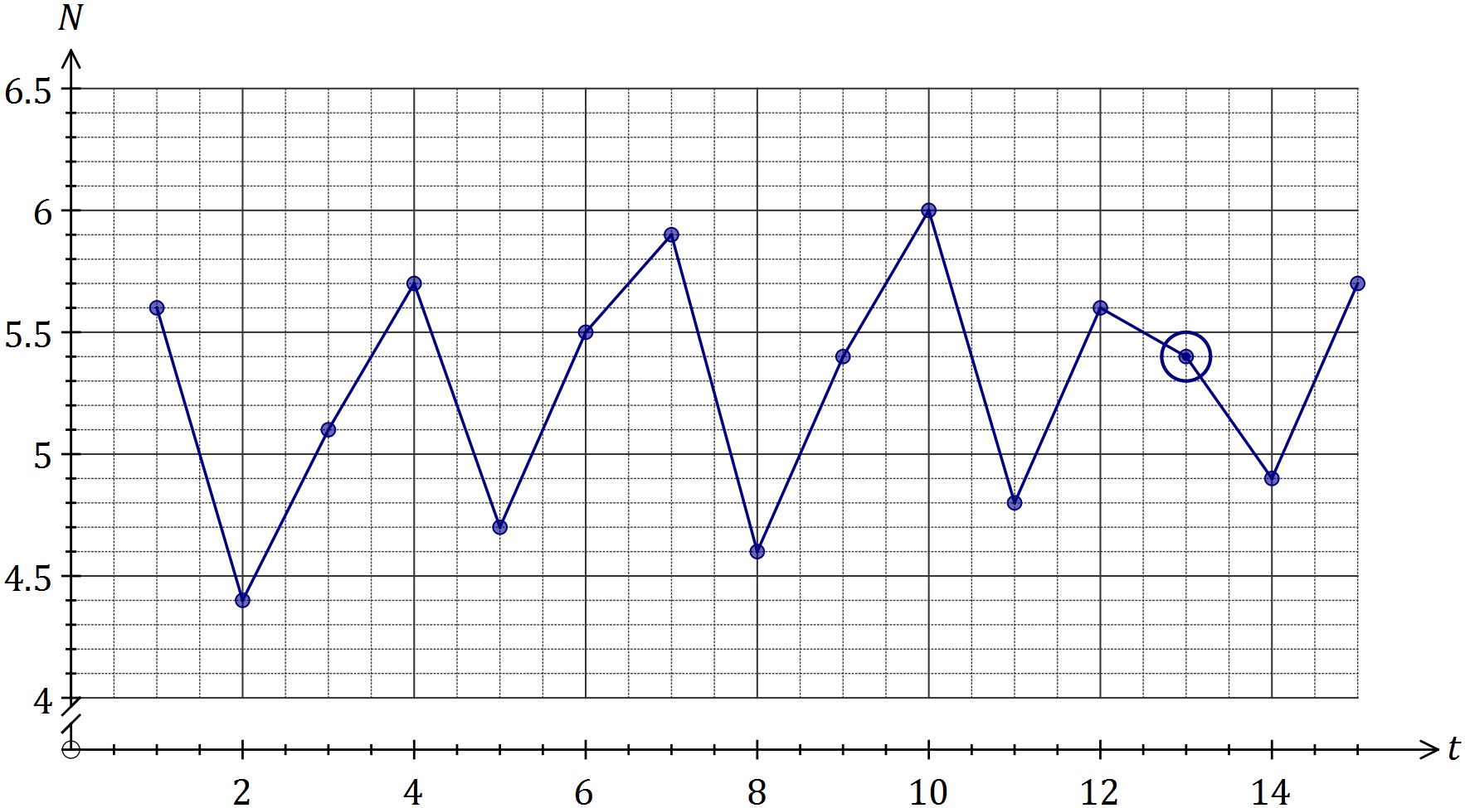

|  |
| --- |
| **Solution** |
| See graph |
| **Specific behaviours** |
| ✓ plots points  ✓ connects points |

(b) One of the data points was suspected of being an outlier. Circle this point on the graph and explain why you chose it. (2 marks)

|  |
| --- |
| **Solution** |
| See graph:  Point does not fit with trend of other morning points. |
| **Specific behaviours** |
| ✓ circles point  ✓ explanation using morning points |

(c) Describe the trend and seasonality of the time series plot. (2 marks)

|  |
| --- |
| **Solution** |
| The overall trend of the time series is increasing.  Within each day, the page views tend to be highest in the morning, decrease to their lowest in the afternoon and then increase again in the night. |
| **Specific behaviours** |
| ✓ describes direction using trend  ✓ describes seasonality within daily cycle |

(d) Calculate the number of page views representing

(i) the three-point moving average for Tuesday afternoon. (2 marks)

|  |
| --- |
| **Solution** |
|  |
| **Specific behaviours** |
| ✓ calculates average  ✓ states units |

(ii) the six-point centred moving average for Wednesday night. (2 marks)

|  |
| --- |
| **Solution** |
|  |
| **Specific behaviours** |
| ✓ uses method involving centering  ✓ calculates average, with units  *\*only penalise units once in part (d)* |

Question 13 (8 marks)

A business took out a loan of $7 500 and made monthly repayments of $390. The table below shows the progress of the loan for the first few months, with repayments and interest applied at the end of each month.

|  |  |  |  |  |
| --- | --- | --- | --- | --- |
| Month | Balance at start of month | Interest | Repayment | Balance carried forward to start of next month |
| 1 | 7 500.00 | 60.00 | 390.00 | 7 170.00 |
| 2 | 7 170.00 | 57.36 | 390.00 | 6 837.36 |
| 3 | 6 837.36 |  | 390.00 |  |

(a) Determine the monthly interest rate. (1 mark)

|  |
| --- |
| **Solution** |
|  |
| **Specific behaviours** |
| ✓ calculates rate |

(b) The recurrence relation to model the loan balance, , in the second column of the table is . State the values of and . (2 marks)

|  |
| --- |
| **Solution** |
| , |
| **Specific behaviours** |
| ✓ states  ✓ states |

(c) Determine the values of and in the table. (2 marks)

|  |
| --- |
| **Solution** |
|  |
| **Specific behaviours** |
| ✓ calculates  ✓ calculates |

(d) Calculate the balance of the loan at the start of month 5. (2 marks)

|  |
| --- |
| **Solution** |
| - balance is |
| **Specific behaviours** |
| ✓ uses correct term of sequence  ✓ calculates balance |

(e) If the business decreased the amount of each repayment, comment on how this would change the total interest accumulated over the life of the loan. (1 mark)

|  |
| --- |
| **Solution** |
| The total amount of interest would increase. |
| **Specific behaviours** |
| ✓ states increase |

Question 14 (7 marks)

A retiree plans to start a pension fund with $750 000 and then withdraw an annuity of $55 000 one year later and then at subsequent yearly intervals. The fund is expected to grow at a rate of 5.4% per annum.

(a) Write a linear recurrence relation to model the total amount in the pension fund, , directly after the th withdrawal. (3 marks)

|  |
| --- |
| **Solution** |
|  |
| **Specific behaviours** |
| ✓ uses correct growth rate  ✓ uses correct withdrawal  ✓ includes |

(b) Determine the number of years that the retiree can withdraw $55 000. (2 marks)

|  |
| --- |
| **Solution** |
| 25 years. |
| **Specific behaviours** |
| ✓ indicates  ✓ states 25 years |

(c) Determine how much can be withdrawn each year if the retiree only wants the fund to last for 10 years. (2 marks)

|  |
| --- |
| **Solution** |
| Withdraw $99 024.12 |
| **Specific behaviours** |
| ✓ calculates payment  ✓ answer uses dollars and cents |

Question 15 (9 marks)

The number of false alarms received by a monitoring station each quarter over the past three years is shown in the graph and table below.

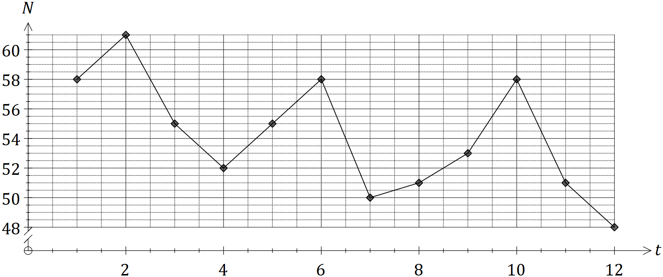

|  |  |  |  |  |  |
| --- | --- | --- | --- | --- | --- |
| Year | Quarter | Time period  (t) | Number of false alarms () | Yearly  mean | Percent of yearly mean |
| 2014 | 1 | 1 | 58 | 56.5 | **A** |
| 2 | 2 | 61 | 108.0 |
| 3 | 3 | 55 | 97.3 |
| 4 | 4 | 52 | 92.0 |
| 2015 | 1 | 5 | **B** | 53.5 | 102.8 |
| 2 | 6 | 58 | 108.4 |
| 3 | 7 | 50 | 93.5 |
| 4 | 8 | 51 | 95.3 |
| 2016 | 1 | 9 | 53 | **C** | 101.0 |
| 2 | 10 | 58 | 110.5 |
| 3 | 11 | 51 | 97.1 |
| 4 | 12 | 48 | 91.4 |

(a) Calculate the values of the entries **A**, **B** and **C** in the table. (3 marks)

|  |
| --- |
| **Solution** |
|  |
| **Specific behaviours** |
| ✓ calculates A  ✓ calculates B  ✓ calculates C |

(b) Three of the four seasonal indices, calculated using the average percentage method, are shown in the table below. Calculate the missing index for quarter 3 and interpret its value. (2 marks)

|  |  |  |  |  |
| --- | --- | --- | --- | --- |
| Quarter | 1 | 2 | 3 | 4 |
| Seasonal index | 1.02 | 1.09 | 0.96 | 0.93 |

|  |
| --- |
| **Solution** |
| Index for Q3:  This index means that in the third quarter, the number of false alarms is slightly below the yearly average. |
| **Specific behaviours** |
| ✓ index calculation  ✓ explanation of below average |

(c) Calculate the deseasonalised number of false alarms for the fourth quarter of 2015.

(1 mark)

|  |
| --- |
| **Solution** |
| Deseasonalised false alarms: |
| **Specific behaviours** |
| ✓ divides by seasonal index |

(d) The equation of the least-squares line to forecast the deseasonalised number of false alarms, , is .

Forecast the **actual** number of false alarms in the second quarter of 2018, assuming that the above seasonality and trends continue. (3 marks)

|  |
| --- |
| **Solution** |
| Trend:  Seasonal adjustment:  Expect 53 false alarms |
| **Specific behaviours** |
| ✓ calculates correct trend value  ✓ makes seasonal adjustment  ✓ rounds to nearest whole number |

Question 16 (9 marks)

The tasks involved in a construction project are shown in the table below.

|  |  |  |  |  |  |  |  |  |  |
| --- | --- | --- | --- | --- | --- | --- | --- | --- | --- |
| Task | A | B | C | D | E | F | G | H | J |
| Duration  (days) | 5 | 8 | 9 | 7 | 8 | 10 | 2 | 11 | 6 |
| Immediate predecessors | - | A | A | B | B | C | D, E, F | C | G, H |

(a) Complete the project network below. (3 marks)

|  |
| --- |
| **Solution** |
| See diagram |
| **Specific behaviours** |
| ✓ D, E, F, H added  ✓ all edges, labelled  ✓ all correct with direction |

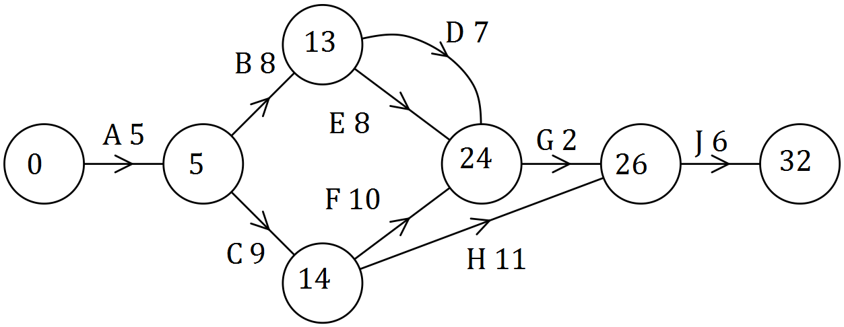

(b) List the tasks on the critical path and state the minimum completion time for the project.

(2 marks)

|  |
| --- |
| **Solution** |
| Critical path is A - C - F - G - J  MCT is 32 days |
| **Specific behaviours** |
| ✓ critical path  ✓ MCT |

(c) If the project is completed in the minimum possible time, determine

(i) the earliest start time for task E. (1 mark)

|  |
| --- |
| **Solution** |
| Day 13. |
| **Specific behaviours** |
| ✓ correct day |

(ii) the latest start time for task B. (1 mark)

|  |
| --- |
| **Solution** |
| . Day 8. |
| **Specific behaviours** |
| ✓ correct day |

(iii) the task with the largest float time, and what this float time is. (2 marks)

|  |
| --- |
| **Solution** |
| Task D - float time of 4 days. |
| **Specific behaviours** |
| ✓ task  ✓ float time |

Question 17 (6 marks)

A competition winner set up a fund on January 1, 2016, with their prize of $500 000. The balance of the fund grew at an annual rate of 3.3%, compounded monthly. Starting on February 1, 2016, the winner withdrew $950 from the fund on the first day of each month.

(a) Determine the balance in the fund just after the withdrawal was made on January 1, 2017.

(2 marks)

|  |
| --- |
| **Solution** |
| Balance was $505 177.85 |
| **Specific behaviours** |
| ✓ indicates 12 withdrawals  ✓ correct balance |

(b) Determine the total amount of interest accrued by the fund during 2016. (2 marks)

|  |
| --- |
| **Solution** |
| $505 177.85 - $500 000 + $950 x 11 = $15 627.85 |
| **Specific behaviours** |
| ✓ Recognises change in principal and withdrawals  ✓ correct total interest |

(c) From January 1, 2017, the annual interest rate applying to the fund decreased and the winner found that the balance of the fund remained the same from month to month. Determine by how much the annual interest rate fell. (2 marks)

|  |
| --- |
| **Solution** |
| decrease. |
| **Specific behaviours** |
| ✓ calculates new rate  ✓ determines change in rate |

Question 18 (6 marks)

(a) $35 000 is invested in a savings account that earns compound interest of 4.2% per annum. Determine

(i) the total interest added to the investment over four years, if interest is compounded annually. (2 marks)

|  |
| --- |
| **Solution** |
|  |
| **Specific behaviours** |
| ✓ calculates future value  ✓ calculates interest |

(ii) the least time, in months, for the investment to accrue a minimum of $16 000 interest when interest is compounded monthly. (2 marks)

|  |
| --- |
| **Solution** |
|  |
| **Specific behaviours** |
| ✓ states time as decimal  ✓ states required time, with units |

(b) $35 000 is invested in a savings account offering 8.8% per annum compounded monthly.

(i) Calculate the effective interest rate for this account. (1 mark)

|  |
| --- |
| **Solution** |
| Effective rate is 9.16% pa |
| **Specific behaviours** |
| ✓ states effective rate |

(ii) Determine the annual rate that a savings account, compounding interest quarterly, would need to offer to achieve the same effective rate as in (i). (1 mark)

|  |
| --- |
| **Solution** |
| Annual rate of 8.86% pa |
| **Specific behaviours** |
| ✓ rate that rounds to 8.86% |

Question 19 (9 marks)

The percentage scores of 19 students in a biology test, , and a physics test, , were recorded and the following statistics calculated:

* the least-squares line to model the relationship is

The residual plot for the linear model is shown below.

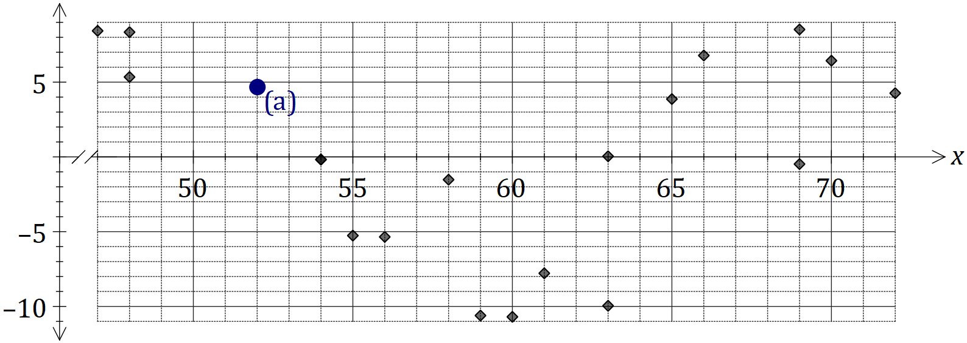

(a) Another student scored 52% in the biology test and 47% in the physics test. Calculate the residual for this student and plot it on the graph above. (3 marks)

|  |
| --- |
| **Solution** |
| See point on graph |
| **Specific behaviours** |
| ✓ calculates  ✓ calculates residual  ✓ plots point |

(b) Use the residual plot to explain whether fitting a linear model to the data is appropriate.

(2 marks)

|  |
| --- |
| **Solution** |
| Linear model is not appropriate as a pattern is clearly evident in the residuals. |
| **Specific behaviours** |
| ✓ states no  ✓ states reason |

(c) What percentage of the variation in the physics scores can be explained by the variation in the biology scores? (2 marks)

|  |
| --- |
| **Solution** |
| so 79% |
| **Specific behaviours** |
| ✓ calculates  ✓ correct percentage |

(d) Are the variables and causally related? Explain your answer. (2 marks)

|  |
| --- |
| **Solution** |
| No. Although it would be reasonable to expect the observed association, strong association is not by itself sufficient evidence for causation. |
| **Specific behaviours** |
| ✓ states no  ✓ states reason. |

Additional working space

Question number: _________

Additional working space

Question number: _________

© 2017 WA Exam Papers. Kennedy Baptist College has a non-exclusive licence to copy and communicate this document for non-commercial, educational use within the school. No other copying, communication or use is permitted without the express written permission of WA Exam Papers. SN245-106-4.